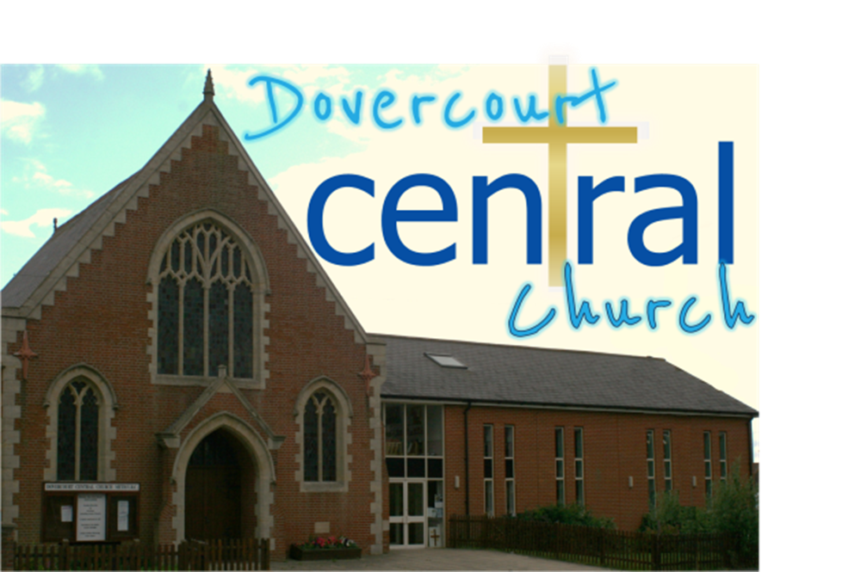

Shell Bay
CONSENT FORM
(Please use a separate form for each child)
Child’s full name:
Telephone number
Emergency contact name: |  | Phone number:
GP’s name |  | GP’s phone number
Any known allergies or
medical conditions
Any additional special needs
I give permission for my child's details to be entered on the Church Data Base: Yes/No I give permission for group photos to be taken of activities: Yes/No
(no individual photographs or names of Children will be published)
I confirm that the above details are complete and correct to the best of my knowledge
In the unlikely event of illness or accident, I give permission for any appropriate first aid to be given by the nominated first-aider. In an emergency, and if I cannot be contacted, I am willing for my child to be given hospital treatment, including anesthetic if necessary. I understand that every effort will be made to contact me as soon as possible.
Parent’s/Guardian’s signature |  |  | Date

Holiday Club 2018

20th – 25th August 2018
10.00am —3.00pm

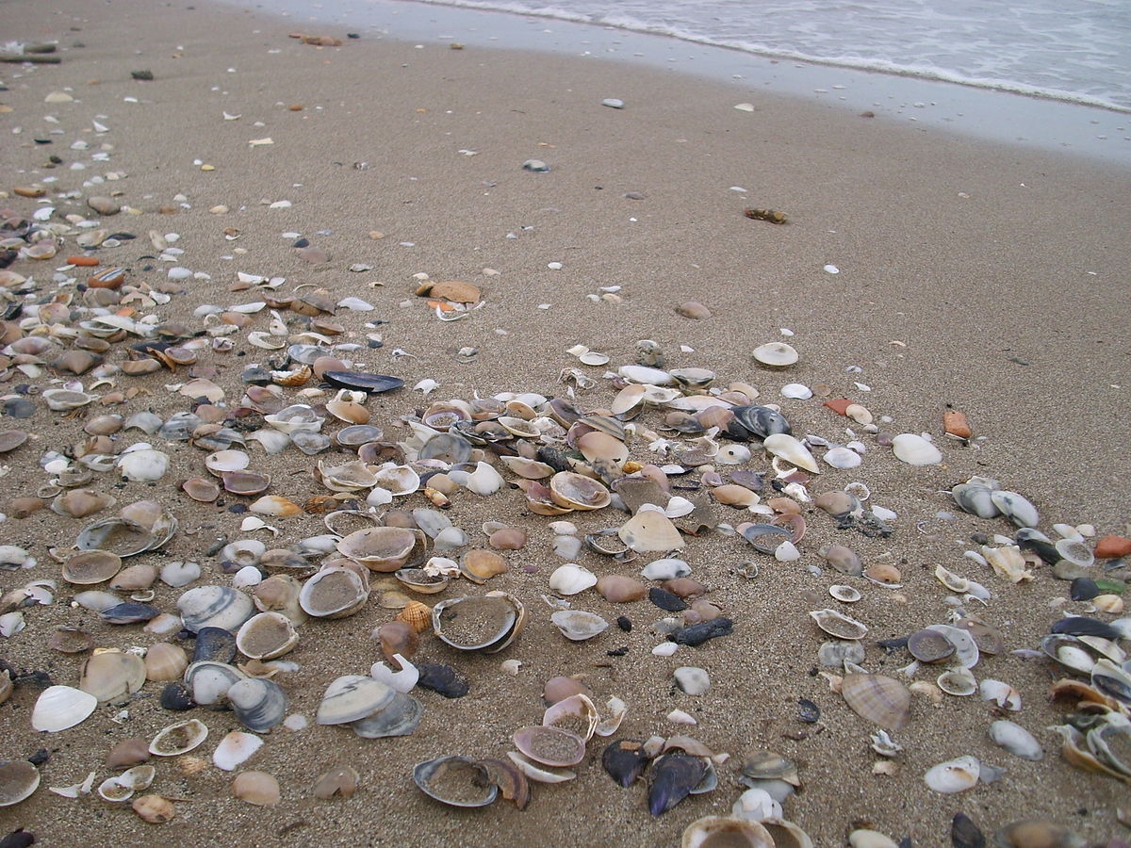
This Photo by Unknown Author is licensed under CC BY-SA

Shell Bay Holiday Club Registration Form
Dovercourt Central Church 203 – 205 Main Road, Dovercourt.
10.00am – 3.00pm 20th – 25th August 2018
(Please use a separate form for each child)
Child’s full name: |  |  |  | Sex: M/F
Date of birth: |  | Current school year:
Parent’s/Guardian’s full name
Address:
Home phone number: |  | Mobile phone number:
Work phone number (if applicable):
Email address:
My Child Will be attending all five days Yes/No
If your Child is unable to attend all five days please state which days they will be unable to attend:
Please register my child for Shell Bay | Parent’s/Guardian’s signature |  | Date
 |  |  | Please complete the consent form on the reverse

What is the Holiday Club?
The Holiday Club is organised by Dovercourt Central Church to take place from Monday 20th – Friday 25th August 2018 between 10.00am and 3.00pm each day.

For more information and a registration form please contact:
Margaret Smith at the Holiday Club email: dccholidayclub@btinternet.com
Or Telephone 01255 504828

The Holiday Club setting will be a beach theme and each day there will fun, games, bible stories, crafts, drama, and music and much more!

Come along and meet ‘Flip and Flop’ the Deckchair attendants, ‘Miss Sauce and Ms. Flake’

Who can attend?
The Club is for Children in school years 1 upwards (6 years), as of June 2018.

How can I book a place for the Club?
Please complete both sides of the Registration/Consent Form and
return it to: -

Mrs. Margaret Smith. 27 Sweden Close, Dovercourt, Harwich, CO12 4JU

Please complete a separate form for each child

There will be daily charge of £1 per child for the club and will be running a tuck shop during the day.

Children need to bring a packed lunch each day.

Spaces are limited so please book in advance to reserve your place.

